Code notes
Licking sensor valve opening time
The Valve opening time can be selected as a function of the volume to be ejected and on the code there is a variable called valveEjectedVolume which is the volume in µL that we want to deliver. This value can be changed in the beginning of the program and can be changed from one experiment to the other.
The time that the valve will remain open is defined by the equation (Figure 1) and is defined as turnOffDelay in the program.
$$V=0.0847t-2.0778$$
$$t=\frac{V+2.0778}{0.0847}$$

Figure 1: relationship between the valve opening time and the delivered volume.
Optical sensors distances
The main constants on the program to measure displacements are the radius which has a value of 9.85, the value of the polystyrene sphere. The conversion_factor is the equivalent of the optical flow sensor internal units in centimeters and it has a value of 123.59. This value is extracted by measuring the perimeter of the polystyrene sphere in the two different axis six times each and establishing the relationship between the actual perimeter of the sphere in cm.
$$actual perimeter=2πr=61.89 cm$$
$$conversion factor=\frac{perimeter measurement}{actual perimeter}$$
For each axis, the measurements are slightly different, for these reason, the value of the conversion_factor is the average value of the 12 samples of one revolution.

Figure 2: Variability of the conversion factor value on the different samples acquired in the two axis (each color is one axis).
The angle is calculated using a conversion factor called cm_to_deg coming from the relationship of the perimeter and the angle:
$$cm to deg=\frac{360°}{2πr} =\frac{360°}{2π(9.85)} \left[\frac{°}{cm}\right]$$
$$angle=cm to deg* distance$$
Encoder
The main constants and variables for the encoder system are:
The radius of the circular platform (Figure 3).
$$r_{1}= 144.3 [mm]$$
The radius of the encoder cylinder (Figure 3).
$$r_{2}=\frac{27.5}{2} [mm]$$
Ratio between the two radius.
$$r_{ratio} = r_{1}/r_{2}$$
The encoder has a resolution of 600 pulses
$$encoder_{resol} = 600 [pulses]$$
The resolution of the system will be the product of relationship of radius and the encoder resolution.
$$system_{resol} = encoder_{resol}*r_{ratio}$$
The resolution of the system is called deg_pulse.
$$deg_{pulse}=\frac{1}{\frac{system_{resol}}{360°}} [\frac{°}{pulse}]$$
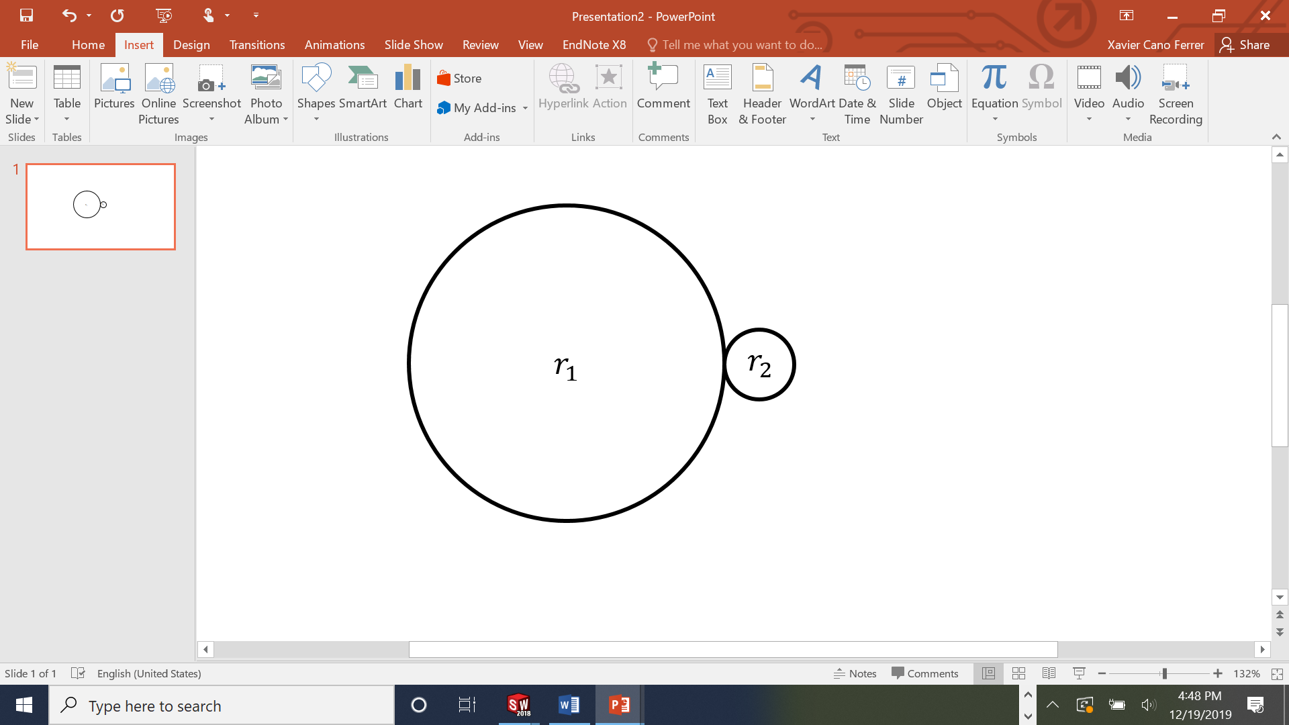
Figure 3: Relationship of radius.
Finally, the encoder absolute angle is the product of the pulse with the resolution of the system.
$$encoder_{angle} =(flag_{A}-flag_{B})*deg_{pulse}$$
DAC output functions
The function to convert the value of the $dl$ into the 12 bit (4096 values) was chosen taking the maximum value registered spinning the sphere on the setup. This in the code is applied to the movement on the two axis on the plane and the rotation.
$$DAC_{out\left[0,2,3\right]}=\frac{2047.5}{max⁡_distance_change }*dl+2047.5= \frac{2047.5}{20 }*dl+2047.5=$$
$$=102.38*dl+2047.5$$

Figure 4: Optical motion sensor DAC function.
In the same way, the maximum $dϑ$ for a certain speed can change from experiment to experiment if the angular velocity is changed. For that reason, in the encoder variables there is a max_angle_change that will change if the angular velocity changes and can be changed to get the maximum range of values of the DAC output or maximum dynamic range for the signal. The function will have the following appearance:

$$DAC_{out1}=\frac{2047.5}{max⁡_angle_change }*dϑ+2047.5$$
In the Figure 5 the function has a max_angle_change of 2 degrees’/time unit.

Figure 5: Encoder DAC function.
The position of the encoder can be displayed in absolute value from -360 to 360 with the following function:
$${DAC}_{out1} = int(5.6875*encoder_angle + 2047.5);$$
We have used this function for recordings in open loop mode where the rotary stage was making a sweep between 360 and -360 degrees.
The signal coming from the licking sensor is a value that from 0 to 1023 values, the equivalent of 10bit resolution and without possible negative values. To convert it into a 12bit resolution signal we only have to multiply it by a $2^{2}$ factor. So the DAC output only multiplies by four:
$$DAC_{out4}=4* licksensor$$

